March 26, 2016

Dear Bridge that Bridges Team Member:

Congratulations on your acceptance to the Bridge that Bridges program! We are deeply excited to have you on the team and to be engaging in this important work together. I am grateful for your commitment and openness to looking at issues of race in our community and creating meaningful art in our neighborhood. Gathering with our neighbors to share our experience is a powerful tool in beginning to address racial issues. Your contributions are important – thank you.

Included with this letter is our schedule for the project. Our first session will be Tuesday, 6PM April 5th at 2320 East 30th St at the Cuyahoga Metropolitan Housing Authority Senior High Rise Community Room, parking can be found in the rear of the building. At our first meeting we will have some food, will get to know one another and start to dig into the project!

If you are under the age of 18 please bring with you the signed permission slip for participation also included with this letter.

Please contact me should any issues arise at kgeschke@campusdistrict.org or 216-287-4535.

The next few months will be a time of growth and fun- we are looking forward to the process!

See you soon!
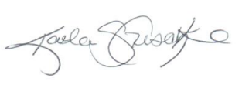
Kaela Geschke
Community Organizer
Campus District
2254 Euclid
Cevleand, OH 44115

“Creativity takes courage.” – Henry Matisse

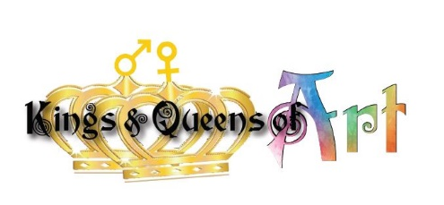
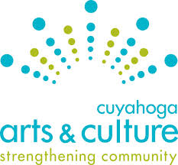
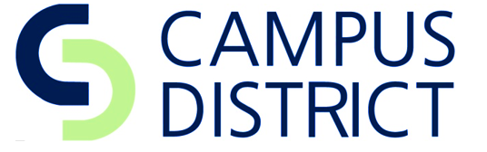

A Bridge that Bridges: Project Sessions

All sessions will take place at 2320 East 30th St at the Cuyahoga Metropolitan Housing Authority Senior High Rise Community Room unless otherwise notified. When we are ready for mural installation we will also be working at the site on the East 22nd St. bridge, notice will be provided. Light food will be provided at each evening session. We will be using our hands and creating art -wear clothes that are comfortable!

Session 1: Meet the Team & Project Overview
Tuesday, April 5th 6-8:00 pm

Session 2: Dialogue & Design
Tuesday, April 19th 6-8:00 pm

Session 3: Dialogue & Design
Tuesday, May 3rd 6-8:00 pm

Session 4: Dialogue & Design
Tuesday, May 17th 6-8:00 pm

Session 5 Dialogue and Artwork
Tuesday, June 7th 6-8:00 pm

Session 6 Dialogue and Artwork
Tuesday, June 21st 6-8:00 pm

Session 7 Mural Installation, Celebration Planning & Reflections
Tuesday, July 12th 6-8:00 pm

Session 8 Mural Installation, Celebration Planning & Reflections
Tuesday, July 26th 6-8:00 pm

Session 9 Mural Installation, Celebration Planning & Reflections
Tuesday, August 9th 6-8:30 pm

Session 10 Mural Installation, Celebration Planning & Reflections
Tuesday, August 23rd 6-8:30 pm

Tentative Date: Friday August 26th
Mural Unveiling and Community Celebration!

“The opposite of love is not hate, it's indifference. The opposite of art is not ugliness, it's indifference. The opposite of faith is not heresy, it's indifference. And the opposite of life is not death, it's indifference.” - Elie Wiesel

About the Bridge that Bridges Project

Campus District and the Kings and Queens of Art will work with a diverse group of residents and stakeholders to create a mural addressing race which will adorn the E.22nd St. bridge separating Downtown Cleveland and the Cedar-Central neighborhood. During the 5 month project the group will meet bi-weekly to engage in intentional conversations about race while designing a community mural depicting your vision of a unified community. We will be using the “Make Art Talk Race” practice developed by local community builders. The mural will be unveiled at a group planned public celebration in August 2016.

Looking for a clearer picture of the process? Check out this youtube video about the practice: https://www.youtube.com/watch?v=-3wmMVI8z4c

Expectations

What YOU Can Expect from the Project:
- a rich and nurturing environment for personal and group development
- light refreshments each session
- a facilitated process for both the conversations and artwork
- FUN!
What the Project Expects from YOU:
- a commitment to participate in all 10 sessions
- shared learning with peers based on your experience and knowledge
- open-minds and hearts
- respectful and honest conversations.

“It helped me to deal with racism to know other peoples’ experience
and how they dealt with it. “
-Josh Hedley

